Prepositions
Baja en el documento y lo amarillo es que esta respondido en clase.
AT | 0-dimensions

1-dimension
2-dimensions public transport
ON

IN | 3-dimensions

- Fill in the blanks with at, on or in:

Andreu, hi ha un PDF amb teoria sobre les preposicions en aquesta propia carpeta.
  - John was standing at the door.

  - There was a notice on the door saying "Do not disturb".

  - I knocked the nail in the door. (Te golpeas la uña con un mazo sobre la puerta. P exemplo)

  - We were swimming in the lake.

  - Today's a holiday and there are a lot of people at the lake.

  - The lake was frozen and we went skating on the lake.

  - I saw Ann on the bus. (Els autobusos son sempre ‘on’)

  - There was no label on the bottle, but there was some delicious wine in it.

  - There was an enormous poster on the wall. (Igual que la 2)

  - The explosion made an enormous hole in the wall. (Reventa la paret I veus a traves d’ella… 3D)

  - We arranged to meet at the bus-stop.

  - He was fined for parking on a yellow line.

+ Movement | Position | - Movement
to | at | away (from)
on[to] | on | off
in[to] | in | out (of)
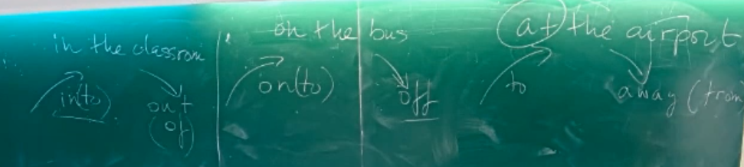
- Fill in the blanks with the appropriate preposition or adverb.

  - You'll have to have that tooth taken out .

  - You mustn't park on a yellow line.

  - Get up, we're going to get off the bus at the next stop.

  - He walked slowly out of the classroom because he was tired after the class.

  - I drive past her house every day on my way to work.

  - We managed to pull him out of the swimming pool.

  - He was so fat that he couldn't get into his old trousers.

  - I usually sit at the table for meals.

  - He fell off the ladder and broke his arm.

  - She had a tattoo on her arm.

  - I've got ink on my hands, I'll have to wash it off. .

  - When I saw the mouse I jumped onto the table.

 | I walked along the path
 | I walked across the road
 | I walked through the building
• | I jumped over the fence
• | I walked under the ladder
• | I walked around the corner
• | I walked past the building

3. Fill in the blanks with one of the prepositions in the table above.

  - They dug a tunnel ............... the wall of the prison.

  - He didn't stop to say hello, he just walked right ............... me.

  - Before landing the plane flew .over Venice.

  - Don't go to/around the forest, you'll probably get lost.

  - It's safer to walk .across the street on a pedestrian crossing.

  - I was walking along the pavement.

over movement  position  covering  more than  text ref. | we flew over the city  there was a cloud over the city  I put the tablecloth over the table  There were over 50 people  can't be used for textual reference
under movement  position  covering  less than  text ref. | they walked under the bridge  there was a cupboard under the sink  He had a shirt under his sweater  There were under 50 people  can't be used for textual reference
above  movement  position  covering  higher level  text ref. | can't be used to indicate movement  there was a cloud above the city  can't be used for covering  It is above average/sea-level  It is ten degrees above zero  As I explained above
below  movement  position  covering  lower level  text ref. | can't be used to indicate movement  there was a cupboard below the sink  can't be used for covering  It is below average/sea-level  It is ten degrees below zero  As you can see below

4.Fill in the blanks with one of the prepositions in the table above.

  - In winter the temperature reaches 20 degrees (lower level) below zero.

  - The horse jumped (movement) .over the fence.

  - I managed to crawl (position) under the table.

  - I'm glad to say that their work is well .above average.

  - I put a sheet over the body.

  - As we shall explain below, this is not the real reason.

  - There were over 100,000 people at the demonstration.

  - As we explained above capitalism is incompatible with respect for the ecosystem.

5.Some metaphorical uses of prepositions.

  - It converts any sequence of written text into speech.

  - There were .above/arround 50 people there, more or less.

  - He's very helpful for a civil servant.

  - When you finish, remember to switch the display off .

  - We have run out paper again.

  - You can rely on her.

  - Do you see that man .in bright red shoes?

  - Only one out off ten students agree with the plan.

  - I had a very strange dream about her.

  - The book is aimed at experienced users.
Prepositions of Time

Fill in the blanks with "at", "on", "in" or “ø”:

- I'll see you on Saturday.

- I've got a lot of work ø this August.

- Let's meet at half six.

- I usually have a light meal in the evening.

- The company was founded in the 19th century.

- I've got a lot of problems at the moment.

- We're having a party ø next Saturday.

- I like to work at night.

- The meeting's on April the first.

- It was a popular group in the eighties.

- They usually go on holiday in August.

- I'll get a couple of weeks off at Christmas.

- I remember that we went to France for our holidays ø that year.

- We can finish it in the morning.

- See you on Monday.

- I'd say he was in his late teens.

- I'll be going to England ø this Christmas.

- She always does a lot of work at the weekend.

RESUMIENDO:
on: Sunday, 25th April

in: years/centuries/ decades, in the morning,

at: time, at night, at present, at the weekend, at Xmas, AtEaster

ø: next, this, that

